HOUSES OF ANCIENT EGYPT
A Nobleman’s House
Near the river in walled gardens with shady palm trees stood the houses of the great nobles. Each villa, built of brick and wood was large and airy. It probably had two storeys, the upper one being for women only. In Thebes itself the land was expensive and only the well-to-do possessed houses several storeys high.
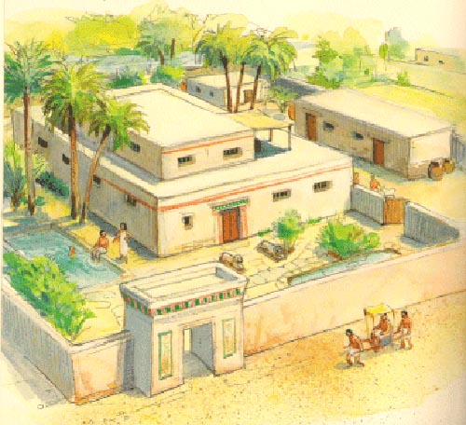
The great houses near the river were gaily decorated with painted walls and patterned hangings. Columns supporting the blue starry ceilings were shaped like palm trees and lotus stalks and the floors were tiled with pictures of fish and other river creatures.
A visitor would enter the house through a portico leading to a spacious entry hall. The central room of the house would sometimes be an open courtyard with the inner rooms leading from it. There were the lord’s private chambers, bedrooms, guest rooms and the women’s quarters.
Outside stood the servant’s rooms, kitchens, stables and by the time of the Empire, the chariot store. There were yards for cattle and a row of corn bins like huge beehives.
Furniture in the house was made of costly wood such as ebony inlaid with ivory. Beds were much like our own and had a mesh of plaited palm fibre where we should have a spring-base. Instead of pillows, wooden neck rests, sometimes richly carved were used.
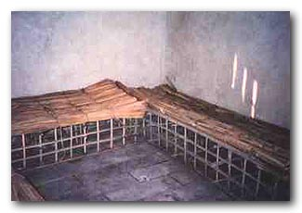
Egyptian houses had no cupboards. Food was kept in large jars and linen and other household goods were stored in wooden chests or skilfully woven baskets.

